**SQL Exercise 2**

1. Display the Supplier table in the descending order of CITY.

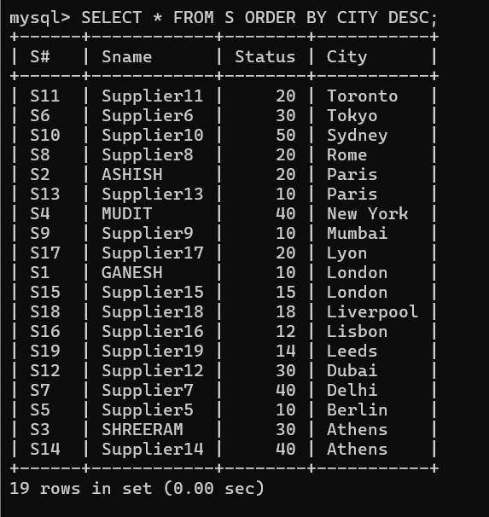

1. Display the Part Table in the ascending order of CITY and within the city in the ascending order of Part names.

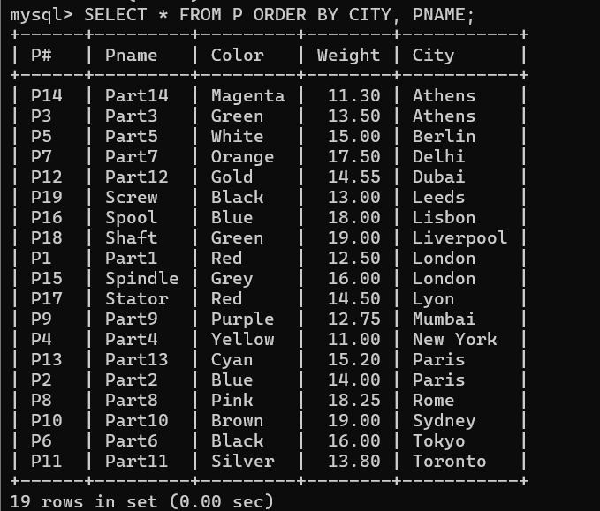

1. Display all the Suppliers with a status between 10 and 20.

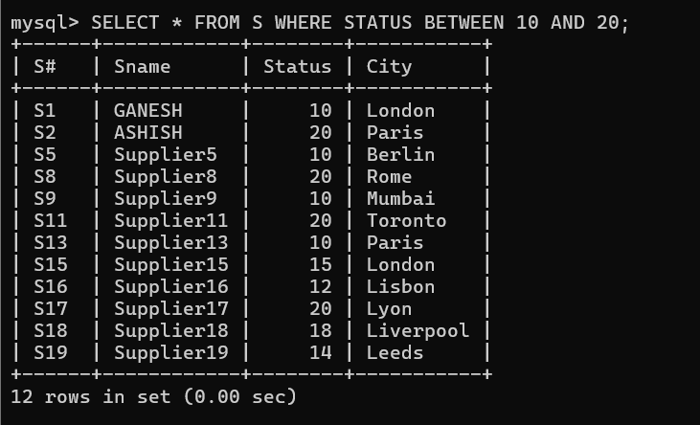

1. Display all the Parts and their Weight, which are not in the range of 10 and 15.

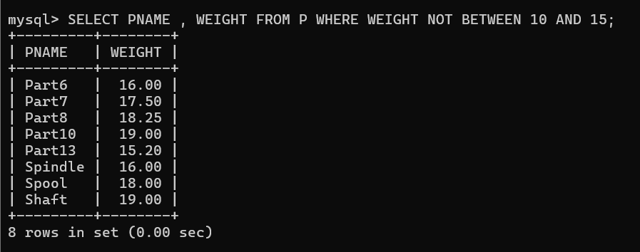

1. Display all the Part names starting with the letter ‘S’.

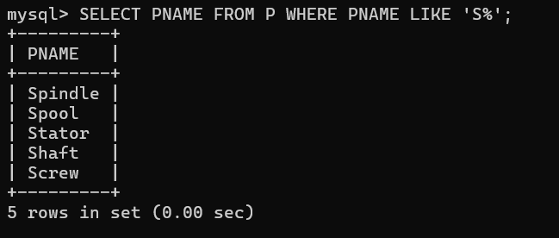

1. Display all the Suppliers, belonging to cities starting with the letter ‘L’.

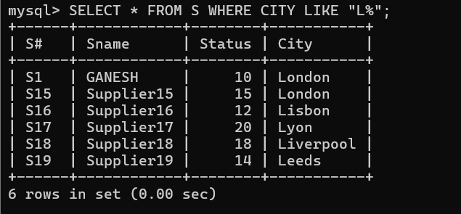

1. Display all the Projects, with the third letter in JNAME as ‘n’.

